HW 6

Elva Fu

Section B

Shopping Cart Lo-fi prototype

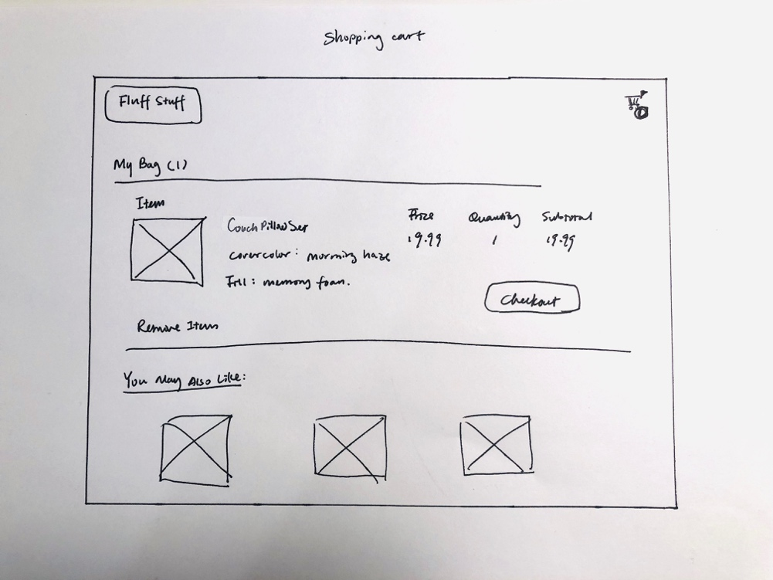

Shopping Cart Hi-fi prototype



Original Invision prototype: <https://projects.invisionapp.com/d/main#/console/15431440/320720577/preview>



The actual coded out page looks more like a table. I changed the design because I did not consider having multiple types of products in the cart at the same time. The subtotal will become confusing. I also removed the navigation bar and “You may also like” section to not distract the user and prompt the checkout process more saliently.

Since I already had the shopping cart page in Assignment 3, I also mocked up a Wishlist page. When the shopping cart page is empty, the Wishlist page will come up to remind the user they have previously favorited something. To accommodate this change, I also changed the “buy now” option on the product detail page to “Wishlist”.

Wishlist Lo-fi prototype

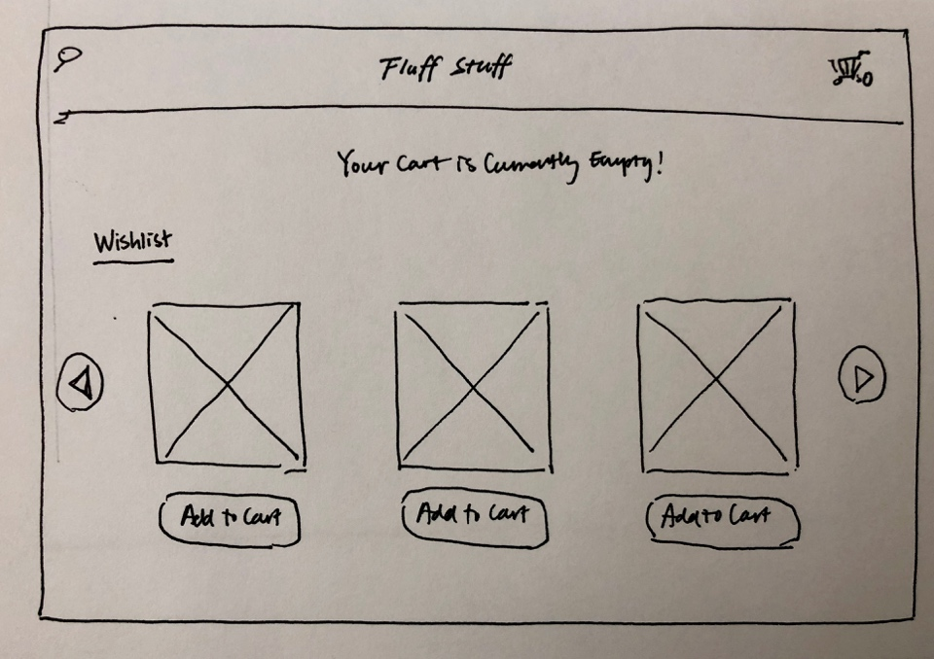

Wishlist hi-fi prototype



Pc: <https://www.familychurch.net/wishlist/>

Reflection:

I’ve encountered many bugs and challenges during this project. Firstly, I did not really understand the logic of JavaScript when I started coding and I was just shooting in the dark. I did not understand when I needed to include something in a function and how would the scope of the variables influence the calculation. Therefore, I watched some tutorials online, read the lab demo code over and over again and went to office hour. When I started to get a grasp of how things works, I also encountered many technical problems as I tackle each of the new features.

The first function I wrote was about changing the picture of the product upon selection a cover option. That one was not so hard after I figured out you can add different value properties to an option from Stack Overflow. So I added data-pic attribute to indicate the picture source and used value to get the name.

Add an item to local storage is more challenging. Fanglin’s office hour was helpful in helping me think about the logic behind this process. Asit also helped us a lot in explaining how to push an object into an array and put into local storage. During this process, I familiarized myself with the debugging aspect of coding. After constantly testing in console and using alert, I finally succeeded.

While adding the items to the cart and displaying it was a challenge, I learned that there are many ways to realize a certain effect. Since I did not know which way is the best, I just learned the first way that makes sense to me, which is appending elements. I learned about it from YouTube video, Stack Overflow, and W3School. However, at a later time, I figured out that this way of adding the items made it hard to delete items dynamically. I wish I would know what’s the ripple effect of using different methods before I start, but that was the learning curve.

For deleting items, I actually struggled a bit before I figure out I needed to add a unique ID to the items added and compare that ID with the delete button ID to delete the row and also from local storage using splice. Thanks Mellissa for teaching me this. Another learning point for me was to consider holistically how things should work together. When there are items added or removed, the shopping cart icon should update to the correct number and when there is no items in the cart, the table header row should not show up. These were tasks that I did not consider before starting to code and that is how I learned coding is also an iterative process rather than anything else.

NOTE: the original prompt only provided four products, I made 6 products on the listing page for the aesthetic when mocking it up. So the fifth and sixth products actually link to repeated couch and bed pillow product detail page.

I made the following changes after in-class critique:

1. Make the logo larger and clickable for better navigation.
2. Make the banner picture a darker color for a better read.
3. Make “Browse All” on homepage look clickable.
4. Change the category navigation on the top of listing page from pictures to buttons to avoid confusion.
5. Move sorting option from bottom of the filter to the top to match convention.